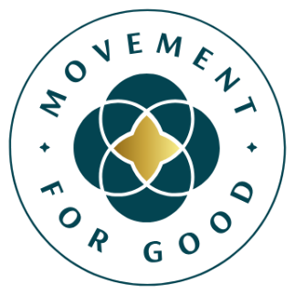
[Insert date]

[Insert name of charity] secures £5,000 funding boost through Benefact Group Movement for Good Awards
Public support helps [Insert your charity] unlock funding for life-changing health and wellbeing work
[Insert name of charity] has received a £5,000 boost thanks to Benefact Group’s Movement for Good Awards – a programme that gives over £1 million in funding to UK and Ireland charities each year.
The charity is one of ten organisations selected to receive a £5,000 grant through the Movement for Good Health and Wellbeing Special Draw, which recognises charities supporting physical and mental health across the UK and Ireland. The winners were chosen from a pool of public nominations.
[Insert brief information about how your charity plans to the use the £5,000 and the impact it will have].
The awards are funded by Benefact Group – a family of specialist financial services businesses, including Ecclesiastical Insurance, a leading insurer of the charity sector. Benefact Group is owned by a registered charity and gives all available profits to good causes. It’s the third-largest corporate donor to charity in the UK in the past decade, having given over £275 million to causes since 2014.
[Insert quote from your charity spokesperson thanking supporters and explaining how the award will help.]
Mark Hews, Group Chief Executive at Benefact Group, said: “We’re delighted to be able to give over £1 million to good causes every year through our Benefact Group Movement for Good Awards, and we’d like to thank every single person who took the time to nominate a cause.
For many health and wellbeing charities, a £5,000 grant can make a real and immediate difference, which is why these awards matter so much. £5,000 can go a long way in the hands of committed charities, and we look forward to seeing the impact this funding will have in communities.
We are also grateful to all our supporters, including the customers of Ecclesiastical and EdenTree, whose continued support helps us back charities making a real difference to people’s health and wellbeing.”
Movement for Good is funded by EIO plc, part of the Benefact Group.

***ENDS***
Notes for editors
Contact details [Who should the journalist contact for more information]
About [your charity]
[Use this space to include some information about your charity, bullet point the information and don’t have more than two or three points here]. For more information visit [insert your web address]
About the Movement for Good Awards
Benefact Group’s Movement for Good Awards is giving away over £1,000,000 in 2026 to help charities change lives for the better. For more information visit www.movementforgood.com
About Benefact Group
Benefact Group is a specialist financial services organisation with a unique mission: to donate all its available profits to charity. As an independent group owned by the registered charity Benefact Trust, its diverse family of businesses - including Ecclesiastical Insurance - offers expertise in specialist insurance, investment management, and broking and advisory services across the UK, Australia, Canada, and Ireland.
Over the past decade, Benefact Group has established itself as the third-largest corporate contributor to charitable causes in the UK, donating over £275m to charities since 2014. Find out more here: www.benefactgroup.com

